[Guideposts](https://guideposts.org/)

[PETS](https://guideposts.org/positive-living/friends-and-family/pets/)

AUTHOR

[Rita Turner](https://guideposts.org/author/rita-turner/)

**Hope Arrives on the Wings of Doves**

* [RITA TURNER](https://guideposts.org/author/rita-turner/)
* 4 MIN READ

A pair of white birds bring unexpected comfort to a grieving mom.

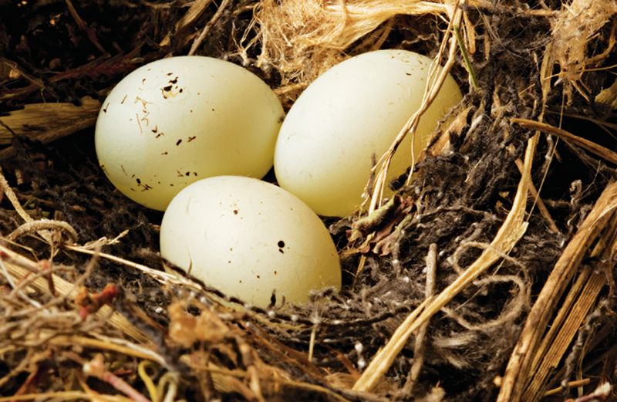

I sat in the breakfast nook with my four-year-old son, Matthew, trying to ignore the ache in my stomach. “Mama, want to play?” Matthew said, rolling his Tonka trucks up and down my leg. I shook my head. “Not today, baby.”

These days I could barely get out of bed. I was still recovering from an emergency hysterectomy to remove a benign tumor. Toys cluttered every room of the house. I hadn’t cooked in ages, relying on casseroles from the ladies at church. I prayed for strength and happiness. But the future seemed so bleak.

“We don’t need a big family,” my husband reassured me. “You and Matthew are all I need.” I couldn’t get past it, though. I’d always wanted five or six kids, ever since I read *Cheaper by the Dozen*in high school. Three miscarriages and one surgery later, that dream would never come to be.

Matthew jumped up from his spot on the kitchen floor. “Birdie!” he squealed, rushing to the sliding glass door that opened onto our courtyard. Sure enough, there was a white dove perched on a rubber tree.

It sat there a few moments, then flew away. Strange. I’d never seen one in our neighborhood before.

When I dragged myself to the kitchen the next morning, the dove was back. This time with a mate carrying twigs. “Look, Matthew,” I said, pointing to the tree. “They’re going to make a nest.” The doves flew in and out of the courtyard all week, building on top of the rubber tree.

Matthew could hardly contain his excitement. Every morning, he’d run into the kitchen and take his spot by the sliding glass door, talking to the birds while they worked. His enthusiasm was contagious. As much as I was grieving, I couldn’t help but look forward to the doves’ visits too.

We watched their progress as if it was a real-life soap opera unfolding before us. I’d make breakfast, scoop Matthew up into my lap, and for a moment, my pain disappeared, replaced by joy.

Then it all went wrong. The courtyard was a safe enough spot for a nest, but the rubber tree’s broad, glossy leaves were far from stable. One night, a gust of wind blew through, flinging the doves’ nest to the ground. I heard the twigs snap apart.

I surveyed the damage. *It figures,*I thought, turning off the kitchen light and heading to bed. *Nothing good ever lasts.*I wouldn’t blame the doves if they never came back.

But they returned. And they paid no attention to the pile of sticks that had once been their nest. They started again from scratch. Again, though, the wind destroyed all their hard work. The next day, and the next, they renewed their efforts, as if immune to despair.

The evening I saw the fourth nest meet its doom, I knew I had to do something. The doves had given me something to look forward to, even on my darkest days. Now I was going to help them in return.

I woke up the following morning with a plan. There was only an hour before the time the doves usually made their visit. I rummaged through the garage for an old piece of shelving.

I leaned a stepladder by the sliding door, hammered the shelf to the wall next to the rubber tree and covered it with leaves so it looked like part of the tree.

Then Matthew and I huddled by the door. Waiting. Hoping.

“The birdies are back!” Matthew announced. There they were–sitting on top of the shelf, adding bits and pieces to the new nest. I danced Matthew around the kitchen. “It worked!”

Two weeks later, we watched three chicks break free from their shells. “Chirp, chirp!” Matthew sang. I held him close and kissed the top of his head, feeling more positive and hopeful than I had in months.

Maybe I didn’t have quite the kind of family I’d imagined. But, all around me, life went on. And it was filled with wonder and surprises, blessings God had in store that I couldn’t even imagine. Like a pair of white doves, building a nest on top of a rubber tree. And me. Waiting. Hoping.