[Guideposts](https://guideposts.org/)

[COPING WITH GRIEF](https://guideposts.org/positive-living/health-and-wellness/life-advice/coping-with-grief/)

AUTHOR

[Rita Turner](https://guideposts.org/author/rita-turner/)

**Baking Her Way Back to Life**

* [RITA TURNER](https://guideposts.org/author/rita-turner/)
* 3 MIN READ

Her grief led her to avoid socializing, but with 96 freshly baked cookies on hand, she

was inspired to reach out for comfort.

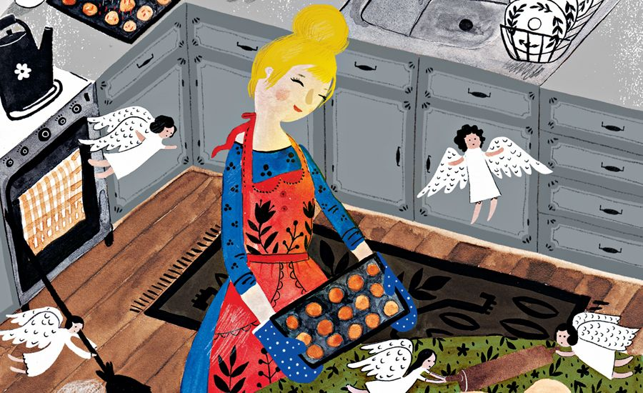

*Mmm…*the rich chocolate chips melted in my mouth. I savored the grainy texture of the sugar on my tongue. I was like a kid when it came to cookie dough and I still had plenty left to bake with. Too much, in fact.

It was true that I’d put on some weight since my husband died—comfort food, always sweets, often cookies. Only I’d comforted myself a bit too much. *This will be my last taste,*I promised myself. I’d agreed to bake for the church get-together at the beach that night—a singles group that met every Friday. Being near the beach was one of the advantages of living in California.

Paul had loved to socialize, but since he died, I’d been hiding out at home. My sister had scolded me over the phone just that morning. “You’re becoming a recluse, Rita,” she said.

I wasn’t looking forward to this gathering, however. In fact, I’d nearly decided to cancel. Then I saw how much cookie dough I’d made. If I didn’t take my cookies to the beach, I would be in danger of eating every last one myself. That couldn’t happen.

I hurried next door to borrow extra baking sheets from my neighbor. “I have more dough than I banked on!” I told her.

“Come in for a few minutes,” she said. “Let’s catch up.”

We chatted for a while before she sent me off with six pans. I hadn’t realized until now how much I missed being in the company of others.

I grabbed a stick of butter from the fridge and greased all the pans—my neighbor’s six and my two. Dollops of dough in neat rows filled all eight pans, a dozen cookies per pan. I stopped to do the math—96 cookies in all!

Baking them was done in shifts. I bent down to watch through the oven window as the first batch bubbled and rose. Then I glanced at the clock—just enough time to finish and clean up before the event.

When the last batch came out of the oven, I set the pans aside to cool and tore off my apron. I laughed when I caught sight of myself in the bathroom mirror—covered head to toe in flour and sticky dough. But I got ready in record time, grabbed a beach chair and my tub of cookies, and loaded my car.

When I showed up at the event everyone came over to hug me or shake my hand. “Welcome back,” they said. “We’ve missed you.” And I’d missed them. Why hadn’t I opened myself to the comfort of this group sooner? We settled around the fire pit, munching on hot dogs. Hickory-tinged smoke from the fire curled in the breeze, as ocean waves heaved in and out.

“Paul would have enjoyed this,” I said, and my friends heartily agreed. It seemed a good time to pass around my cookies. “I can’t imagine why I made so many,” I told everyone. No one seemed to mind.

The cool night air was filled with laughter and chatter, much of it coming from me. We made bets on what time the sun would set and all clapped when it did. As I went back to my car after all the good-byes—without one leftover cookie—it occurred to me that I enjoyed socializing just as much as Paul.

*How do you like that, honey?*I thought to myself. No wonder I’d wound up with way too much cookie dough. Angels must have tripled the sugary recipe so I would have to come here and share and discover the healthy sweetness of fellowship.

*Did you enjoy this story? Subscribe to*[Angels on Earth](http://bit.ly/angelsonearthsub) *magazine*.